1.

If P = {2,3,5,7} and Q = {2,4,6,8}, find P∩Q.
A.
{2}
B.
{3}
C.
{4}
D.
{5}

2.

Which of the following numbers is an integer?
A.
-
5
4
B.
-
2
3
C.
0.5
D.
1

3.

Find the Lowest Common Multiple (LCM) of 2² x 3 x 5² and 2³ x 3² x 5.
A.
2² x 3 x 5
B.
2² x 3² x 5²
C.
2³ x 3 x 5
D.
2³ x 3² x 5²

4.

How many diagonals are in a rectangle?
A.
1
B.
2
C.
3
D.
4

5.

Simplify -4(3-5)+10-3(7+4)+30.
A.
-1
B.
15
C.
56
D.
65

6.

An iron rod 15 m long is divided into 12 equal parts. How long is each part?
A.
0.80 m
B.
1.25 m
C.
1.50 m
D.
3.00 m

7.

Convert 42 to a base two numeral.
A.
1001010_{two}
B.
1010010_{two}
C.
1010100_{two}
D.
101010_{two}

8.

Simplify
5
7
x
5
4
5
2
A.
5⁷
B.
5⁸
C.
5⁹
D.
5¹³

9.

A tank contains 400 litres of water. If 100 litres is used, what percentage is left?
A.
25%
B.
30%
C.
40%
D.
75%

10.

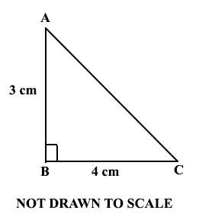
Triangle ABC is a right-angled triangle. Find the length of AC.
A.
1 cm
B.
5 cm
C.
7 cm
D.
12 cm

11.

Arrange the following fractions in descending order of magnitude:
2
3
,
5
7
,
2
5
,
1
2
.
A.
5
7
,
2
5
,
2
3
,
1
2
B.
5
7
,
2
3
,
1
2
,
2
5
C.
1
2
,
2
5
,
5
7
,
2
3
D.
1
2
,
5
7
,
2
3
,
2
5

12.

Find the image of 3 under the mapping, x → 10 - 2x.
A.
4
B.
5
C.
8
D.
16

13.

Simplify
1
3
+
1
9
+
1
27
A.
5
27
B.
7
27
C.
11
27
D.
13
27

14.

If 2x = 5(x - 2) + 7, find the value of x.
A.
-5
2
3
B.
-1
C.
1
D.
5
2
3

15.

The table below shows the day and night temperatures of a town during a week. Use it to answer the question below.
Week | Temperature (ºC)
Week | Day | Night
Monday | 33 | 24
Tuesday | 29 | 25
Wednesday | 32 | 23
Thursday | 34 | 26
Friday | 32 | 24
Saturday | 30 | 24
Sunday | 30 | 25
Find, correct to one decimal place, the average day temperature for the week.
A.
24.4 ºC
B.
30.2 ºC
C.
31.4 ºC
D.
32.2 ºC

16.

The table below shows the day and night temperatures of a town during a week. Use it to answer the question below.
Week | Temperature (ºC)
Week | Day | Night
Monday | 33 | 24
Tuesday | 29 | 25
Wednesday | 32 | 23
Thursday | 34 | 26
Friday | 32 | 24
Saturday | 30 | 24
Sunday | 30 | 25
On which day was the change in temperature the least?
A.
Monday
B.
Saturday
C.
Sunday
D.
Tuesday

17.

A box contains 30 identical balls of which 16 are white and the rest yellow. If a girl picks a ball at random from the box, what is the probability that it is a yellow ball?
A.
1
16
B.
7
15
C.
8
15
D.
7
8

18.

Find the truth set of
1
4
(x + 3) ≤ 2x - 1.
A.
{x:x ≤ -3}
B.
{x:x ≤ -1}
C.
{x:x ≥ 1}
D.
{x:x ≥ -3}

19.

The perimeter of the figure below is 71 cm. Find the diameter of the semi-circumference portion.
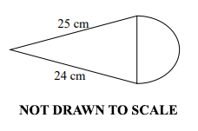
[Take π =
22
7
]
A.
1.0 cm
B.
3.5 cm
C.
7.0 cm
D.
14.0 cm

20.

Simplify
3x
4
-
x - y
3
.
A.
5x - 4y
12
B.
13x - 4y
12
C.
5x + 4y
12
D.
13x + 4y
12

21.

Kojo is 20% heavier than Afua. If Kojo weighs 6 kg, what is Afua’s weight?
A.
4.8 kg
B.
5.0 kg
C.
6.0 kg
D.
7.2 kg

22.

Find the volume of a cylinder of height 3 cm and radius 2 cm.
A.
6π cm³
B.
12π cm³
C.
18π cm³
D.
24π cm³

23.

Given the points S(5, -2) and T(3, 2), calculate the gradient of the line ST.
A.
-2
B.
-
3
5
C.
1
2
D.
2

24.

Kofi invested GH₵ 150,000 at 2.5% per annum simple interest. How long will it take this amount to yield an interest of GH₵11,250.00?
A.
2 years
B.
3 years
C.
4 years
D.
5 years

25.

Express 3.75 as a mixed fraction.
A.
3
1
5
B.
3
1
4
C.
3
1
3
D.
3
3
4

26.

A map is drawn to the scale 1:100,000. What distance in kilometres is represented by 5 cm on the map?
A.
0.5 km
B.
5.0 km
C.
50.0 km
D.
500.0 km

27.

Given that r =
(
-3
4
)
and s =
(
1
-3
)
, find r - 2s.
A.
(
-5
1
)
B.
(
-5
10
)
C.
(
-2
10
)
D.
(
-1
10
)

28.

Esi went to the market and bought 500 g of meat, 850 g of fish and 900 g of eggs. What is the total weight of the items she bought in kilograms?
A.
2.20 kg
B.
2.25 kg
C.
2.35 kg
D.
22.50 kg

29.

A watch gains 1
1
2
minutes per hour. What is the total time gained from 12 noon to 12 midnight in a day?
A.
9 minutes
B.
15 minutes
C.
18 minutes
D.
36 minutes

30.

A printing machine prints 600 books in 3 hours. How many books will the machine print in 5 hours?
A.
360 books
B.
1000 books
C.
1800 books
D.
3000 books

31.

The bearing of Atoru from Busase is 275°. What is the bearing of Busase from Atoru?
A.
180°
B.
175°
C.
095°
D.
075°

32.

In a class of 24 pupils, 10 study French only and 8 study English only. If each pupil studies at least one of the two subjects, how many study English?
A.
12
B.
14
C.
16
D.
18

33.

Convert 84 to a base five numeral.
A.
4130_{five}
B.
3014_{five}
C.
314_{five}
D.
114_{five}

34.

In the diagrams below, triangle A₁B₁C₁ is an enlargement of triangle ABC. Determine the scale factor.
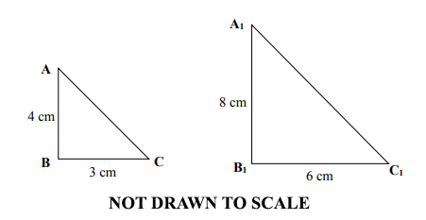
A.
0.50
B.
0.75
C.
2.00
D.
4.00

35.

Find the least number that must be added to 308 to make it divisible by 19.
A.
4
B.
7
C.
15
D.
18

36.

In a school of 940 pupils, the number of girls exceeds the number of boys by 150. How many girls are there in the school?
A.
620
B.
545
C.
470
D.
395

37.

Which of the following fractions is equivalent to
3
5
?
A.
21
30
B.
12
20
C.
15
45
D.
6
15

38.

(38)
In the diagram below, line PQ is parallel to RS and UV is a line drawn through PQ and RS.
Use the diagram to answer the question below.
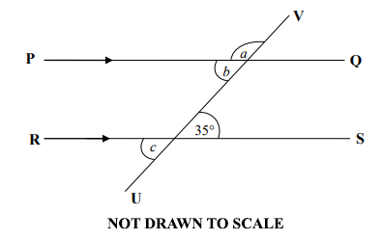
Find angle a.
A.
35º
B.
55º
C.
135º
D.
145º

39.

In the diagram below, line PQ is parallel to RS and UV is a line drawn through PQ and RS.
Use the diagram to answer the question below.
Angle b and angle c are
A.
alternate angles.
B.
vertically opposite angles.
C.
corresponding angles.
D.
interior opposite angles.

40.

Expand – x(3 – 2x).
A.
-2x² - 3x
B.
2x² - 3x
C.
-2x² + 3x
D.
2x² + 3x

